**Att.:** Lars Erik Johannessen. **E-mail:** l.e.johannessen@nhm.uio.no. **Ph#:** +4722851801. **Fax#:** +4722851837

**Shipping documentation / Customs declaration**

**Scientific research specimens, not restricted**

**Special provision A180 applies**

Preserved museum specimens (avian blood samples) for scientific research, originally preserved and subsequently stored in 96 % ethanol (UN1170, PG II). The specimens are packed in accordance with **IATA SP A180**.

The package contains the following species, none of which are CITES listed:

*Linaria flavirostris*  
*Rhodospiza obsoleta*  
*Serinus syriacus*  
*Carpodacus synoicus*  
*Rhodopechys alienus*

The specimens are on loan for molecular biodiversity research and legally belong to the Natural History Museum, Oslo (Country of origin: Norway). They are biologically inactive, non-infectious, non-contagious, non-venomous, unfit for human consumption, no traded goods, have no commercial value and are not for resale.

Loan number: **BI-361**

|  |  |
| --- | --- |
| **Total volume of ethanol per inner packing:** | 0.5 mL |
| **Total volume of ethanol per outer packing:** | 2.5 mL |
| **UN Code:** | UN1170 |
| **HS Code:** | 9705.29.00 |
| **Declared value:** | 50.00 NOK |

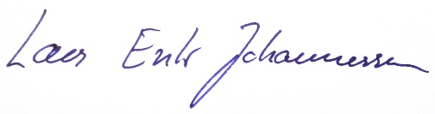

..................... ........................................

Lars Erik Johannessen

Oslo, 11 November 2022